Lesson Overview
In this TI-Nspire lesson, students will investigate scatter plots of paired variables. Students practice interpreting points in context and look for overall trends among the data. Students will also look for trends among the bivariate data as they are associated with specific categorical variables. |  |  | Learning Goals
- Interpret points represented in a scatter plot in terms of the context represented by the paired variables;
- identify and interpret clusters, gaps and outliers in a scatter plot;
- describe patterns/trends in a scatter plot and identify possible associations between the variables and particular categories.
 | A scatter plot of paired measurement variables can often be described in terms of clusters, gaps, and unusual data points. They can also be described in terms of the spread of the values on the two axes.
Prerequisite Knowledge |  |  | Vocabulary
Scatter plots is the twenty second lesson in a series of lessons that explore the concepts of statistics and probability. This lesson builds on the concepts of the earlier lessons Introduction to Data and Analyzing Distributions. Students should understand:  - plotting points on coordinate planes;  - shape center and spread of univariate data sets;  - outliers in a univariate distribution. |  |  | - scatter plot: a graph of plotted points that show the relationship between two sets of data.  - association: a relationship between groups  - response variable: the dependent variable
Lesson Pacing
This lesson should take 50–90 minutes to complete with students, though you may choose to extend, as needed.
Lesson Materials
- Compatible TI Technologies:
TI-Nspire CX Handhelds, TI-Nspire Apps for iPad®, TI-Nspire Software
- Scatter Plots_Student.pdf
- Scatter Plots_Student.doc
- Scatter Plots.tns
- Scatter Plots_Teacher Notes
- To download the TI-Nspire activity (TNS file) and Student Activity sheet, go to http://education.ti.com/go/buildingconcepts.

Class Instruction Key
The following question types are included throughout the lesson to assist you in guiding students in their exploration of the concept:
Class Discussion: Use these questions to help students communicate their understanding of the lesson. Encourage students to refer to the TNS activity as they explain their reasoning. Have students listen to your instructions. Look for student answers to reflect an understanding of the concept. Listen for opportunities to address understanding or misconceptions in student answers.
Student Activity: Have students break into small groups and work together to find answers to the student activity questions. Observe students as they work and guide them in addressing the learning goals of each lesson. Have students record their answers on their student activity sheet. Once students have finished, have groups discuss and/or present their findings. The student activity sheet can also be completed as a larger group activity, depending on the technology available in the classroom.
Deeper Dive: These questions are provided for additional student practice and to facilitate a deeper understanding and exploration of the content. Encourage students to explain what they are doing and to share their reasoning.
Mathematical Background
A scatter plot of paired measurement variables can often be described in terms of clusters, gaps, and unusual data points, much as in the univariate situation. (Note the term outliers could be used here, but the definition in terms of the interquartile range does not apply in a two variable situation.) Interpreting points in a context can reinforce understanding of the location of points and the pair of quantities they represent. Students often only look at individual points, missing any overall patterns, clusters or trends, and, as a consequence, they need practice considering the information contained in a scatter plot more generally. Connecting plots of paired variables to plots of single variables allows students to build on the same notions of shape, center and spread they considered in describing distributions of a single variable. Scatter plots can also be described in terms of the spread of the values on the two axes, and a central cluster of points can lead to an informal notion of a “typical” point with respect to the context. (This will become the point (mean x, mean y) in further studies using a more technical approach.)
A point in a scatter plot represents a pair of quantities that have been observed for a single object. Visualizing those points in a scatter plot representing members of a particular category can reveal an association that might exist between category membership and one or both of the paired quantities.

Resources:
www.basketball-reference.com/awards/slam_500_greatest.html
www.basketball-reference.com/players/

Part 1, Page 1.3
Focus: Interpreting scatter plots in a context can reveal information about the relationships between the paired observations used to generate the plot.  On Page 1.3, students can select menu> x-axis; menu> y-axis to display scatter plots of statistics for the "all-time greatest" professional basketball players based on various career statistics. | 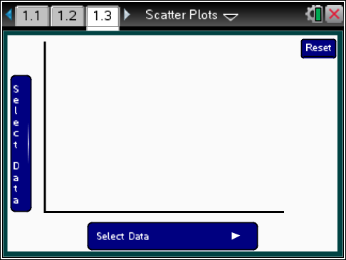
 |  |  | TI-Nspire Technology Tips
b accesses page options.
e cycles through points and selects data for each axis.
· selects /deselects points.
d deselects all selected points
/. resets the page to the original screen.
Hovering over a point displays the stats for the player associated with that point; selecting a point highlights it in blue and displays the stats, which remain on the screen until another point is selected and it turns red. Select the point again or select a white space to deselect.
Select Data on either axis, chooses the variable for that axis.
Position highlights all players in that position.
V-axis displays dot plots of the statistics relevant for the vertical axis in the scatter plot of the paired variables. Also accessible by pressing V on the keypad.
H-axis displays dot plots of the statistics relevant for the horizontal axis in the scatter plot of the paired variables. Also accessible by pressing H on the keypad.
Class Discussion
Teacher Tip: The following questions are intended to help students read and interpret individual points in the context of the scatter plot as well as relate the location of the point to the interpretation, e.g., the larger the value for the horizontal axis, the farther the point is to the right. Then students shift from looking at individual points and people in the scatter plots to analyzing the plots with respect to the location of certain subgroups. Students should note that highlighting subgroups of the entire population can reveal patterns or clusters that might be visible among the subgroups or the relation of the subgroup to either of the variables.

Class Discussion (continued)
The TNS activity contains lifetime statistics about a set of “the greatest” professional basketball players as determined by a variety of sources. Graph the average number of points per game on the horizontal axis and free throw percentage on the vertical axis.
Have students… | Look for/Listen for…
- Identify the players with the highest average number of points per game. Where are they located in the plot? How do they compare with respect to shooting free throws? | Answers will vary. Wilt Chamberlain and Michael Jordan, located the farthest to the right in the plot, have the highest average number of points per game, 30.1. Jordan has a high free throw percentage, 83.5%, while Chamberlain has the lowest free throw shooting percentage of all the players, 51.1%.
- Identify the players with the highest free throw shooting percentage. Where are they located and how do they compare to the other players? | Answer: Steve Nash, represented by the highest point on the grid, has the largest free throw percentage, 90.4%. He averaged 14.3 points per game, which was a bit lower than most of the other players.
- At the end of the 2015 season, LeBron James had a career average of 27.3 points per game. What was his free throw shooting percentage? | Answer: 74.5%.
- How does James compare to the rest of the players with respect to points per game and free throw shooting percentage? | Answer: James is 4th highest in terms of points per game and a bit below the middle in terms of free throws.
- Where are the players with the lowest numbers with respect to both of the variables? Identify the players. | Answers may vary. The players with the lowest numbers will be in the lower left corner. Dennis Rodman with 7.3 points per game and making 58.4% of his free throws and Wes Unseld with 10.8 points per game and making 63.3% of his free throws seem to be lower for both variables than the other players. Some students might suggest Bill Russell as well.
- Which players seem to do the best with respect to both points per game and free throw shooting? Explain your reasoning. | Answers may vary. Michael Jordan has the largest average number of points per game and is about tenth in free throw shooting percentage. Some students might argue for other players, for example Rick Berry with a high free throw percentage (90%), but 15 players have a higher average number of points per game than his 23.2.

Class Discussion (continued)
Dennis Rodman was one of the players with the lowest number of points per game. Select his point in the plot.
- How did Rodman compare in terms of rebounds? | Answers may vary. Rodman’s average number of rebounds was larger than all but 10 of the other players.
- Change the horizontal axis to represent the average number of assists. (An assist is when a player passes the ball to another player who then makes a basket.) How did Rodman perform in terms of assists? | Answers may vary. Rodman was in the lowest three or four players in terms of assists.
- Change the horizontal axis until you find an area besides rebounds in which Rodman performed well. Describe what you are looking for as you check the scatter plots of the different statistics. | Answers may vary. The goal is to find a scatter plot where the dot representing Rodman is towards the top of the grid. This happens on the plot (field goal percentage, average number of rebounds), where Rodman’s field goal percentage is 52.1%, better than all but six of the other players.
Three-point shots were not identified officially until the 1979-80 basketball season. Graph (field goal percentage, three-point percentage).
- Wes Unseld had the highest three-point percentage. What was his percentage and what does it mean? | Answer: He had a 50 three-point percentage, which means he made half of the three-point shots he took.
- Unseld played from 1968–69 until the end of the 1980–81 season. Explain what might have been a factor in his high three-point percentage. | Answers may vary. The base used in calculating a percentage is not visible. It is important to remember that and are both 50%, so one reason might be that Unseld took very few shots. In fact, Unseld took 2 three-point shots in 1970-80 and made one, 4 three-point shots in 1980-81 and made two, so overall he attempted 6 three pointers and made 3 of them for a 50% average.
- Steve Nash played from 1997–98 to 2013–14. Find Nash on the plot. If he made 3939 three-point attempts, what was his percentage? | Answer: His percentage was about 43%, so he made1685 of his three-point attempts.
- Unseld was a center. Overall, how did the “greatest” centers do at making three point shots? | Answer: Centers were typically not good at making three point shots with most of them making less than 30% of their shots.
Student Activity Questions—Activity 1
1. Plot (average number of points per game, average number of rebounds per game).
- Identify any points that strike you as “outliers”—points that lie quite outside of the general set of points. Who are the players and how do they compare to the other players?
Answer: Wilt Chamberlain, in the top right corner, averaged 30.1 points per game and 22.9 rebounds, clearly better than all of the other players with respect to both variables. Bill Russell, towards the top a bit left of the middle, averaged 22.5 rebounds per game but was lower than most of the other players with respect to the average number of points, 15.1. Dennis Rodman has the least number of average number of points per game but is just over 3 less than Wes Unseld scored.
b. Identify the players with the least number of rebounds per game. How did they do with respect to points per game?
Answer: The player with the lowest average number of rebounds per game was Tiny Archibald with 2.3. Lots of other players were close however, and they all, including Archibald, had between 13 and 19 points per game, towards the lower end of all the players.
2. Basketball players generally play one of five positions, center, point guard, shooting guard, small forward, and power forward. Plot (average number of rebounds, field goal percentage). Select menu> Position, and experiment with the different positions with respect to the plot.
a. What are some observations you have with respect to any association between position and either rebounds or points scored?
Answers may vary. The centers are the ones who make most of the rebounds per game, typically 9 to 17, and scored more rebounds than all but six of the other players. Russell and Chamberlain were “outliers”- scoring 22.5 and 22.9 rebounds per game averaging about 6 more rebounds than the next highest center, Bob Pettit at 16.2. Some of the centers had a high field goal percentage (like Shaq O’Neal with 58.2%, Dwight Howard with 57.9% or Kareem Abdul-Jabbar with 55.9%) and others hardly any (like Dolph Schayes with 38%).
- Change the vertical axis to number of assists (an assist is a situation in which one player passes the ball to a teammate who makes a basket). What do you observe?
Answers may vary. The centers make more rebounds than all but seven of the other players, but none of them made more than a bit over 4 assists.
- Plot (free throw percentage, three point percentage). Describe where the players in different positions seem to cluster in the plot.
Answers may vary. Shooting guards, with the exception of Dennis Johnson, and small forwards seem to cluster in the upper right of the plot, with high percentages in both categories. Point guards are also clustered in the upper right corner, with relatively high percentages for both but maybe not quite as strong as the other shooting guards and small forwards. All but four of the centers make less than 25% of their three point shots. Power forwards are mixed.

Part 2, Page 1.3
Focus: Students make general comments about scatter plots based on: how the points are distributed across the axes, “typical greatest” players, and whether any trends or associations between the variables are apparent.
Class Discussion
Teacher Tip: The following questions help students confront the tendency to think about a scatter plot in terms of individual points by asking for some general statements about the plots and lay a foundation for Activity 23, Modeling Linear Relations. The final question in the student activity introduces the notion of a response variable (relating it to the earlier term, dependent variable) and of looking at patterns in scatter plots in terms of predictability—can knowing the independent variable help you predict the response variable?
Plot (average number of minutes per game, average number of points).
- Select several points and observe the coordinates. Describe the spread of the average number of minutes played per game and the spread of the average number of points for all the players. | Answer: The average number of minutes played per game goes from 17.9 (McHale) to 45.8 (Chamberlain). The average number of points per game goes from 7.3 points (Rodman) to 30.1 (Chamberlain).
- Imagine the points mapped onto the horizontal axis. Select H. Axis. Describe the distribution of the players’ average number of minutes per game. | Answers may vary. For example, the distribution of the average number of minutes per game is relatively mound shaped and symmetric, with most players averaging between 34 and 38 minutes. The range of playing time for these players was 14.8 minutes, from 31 minutes to 45.8 minutes per game. Chamberlain would be an outlier, as he was in the games way more minutes than the rest of the players.
- Select H. Axis again to return to the scatter plot. Imagine the points mapped to the left onto the vertical axis, then Select V. Axis. Describe the distribution of the players’ average number of points per game in terms of the context. | Answers will vary. The distribution of the average number of points per game is skewed a bit downward, with lots of the players scoring between around 18 and 26 points a game. Overall, the range of the scores was 12.2 points, from 17.9 to 30.1

Class Discussion (continued)
- Describe the typical “greatest” player in terms of average number of minutes and average number of points per game. Explain your reasoning. | Answer may vary. Using the information from parts b) and c), the typical greatest player seems to average about 36 or so minutes per game and about 21 points per game.
- Identify any of the points that seem to represent players who are “outliers” with respect to the other players in terms of minutes played and points scored? Explain why they seem to be outliers. | Answers may vary. Wilt Chamberlain and Michael Jordan have the same number of points per game. 30.1, but Chamberlain with 45.8 minutes per game is way ahead of the other players, which makes him an outlier. The closest are about 6 minutes per game less- Russell (42.2 min) and Robertson (42.3 min). Students might argue that Russell is an outlier for a high number of minutes but low number of points scored or that Rodman is an outlier for being low in both categories.
Sometimes the variables in a scatter plot display a trend or pattern. Just as in thinking about the shape, center and spread of a distribution of a single variable, however, if moving three or four points changes the trend, then it is probably not a very strong trend. Use the plot (minutes played per game, average number of points scored). Which of the following statements make sense in terms of the scatter plot? Use data from the plot to support your thinking.
- The longer players are in the game, the more points they score. | Answers will vary. This statement seems to make sense because there are players where both statistics are low, like John Stockton (31.8, 13.1) and they go up to players where both statistics are high, like Allen Iverson (41.1, 26.7), Oscar Robertson (42.2, 25.7) and Wilt Chamberlain (45.8, 35.1).
- The longer players are in the game, the fewer points they score. | Answer: This does not seem to be true, using examples like those for the question above.
- If a player doesn’t play very many minutes, they don’t seem to score many points | Answers may vary. This seems to be true for at least four maybe six players including Stockton.
- There seems to be an association between the number of minutes a player is in the game and the number of points they score. | Answer may vary. This seems to be true; the longer you play the more points you score.

Student Activity Questions—Activity 2
1. Does there seem to be an association or relationship between the statistics in each of the following scatter plots? Explain your thinking.
a. (field goal percentage, three-point percentage)
Answers may vary. Not really any relationship; the points are scattered all over with no real pattern, so there does not seem to be any association between field goal percentages and three-point percentages. If you moved the three points in the lower right (Abdul-Jabbar, Howard, O’Neal), the points do not show any real trend.
b. (average number of rebounds per game, average number of points per game)
Answer: No association. Michael Jordan made a lot of points (averaged 30.1 but only 7 rebounds per game; A bunch of players were in the lower left corner with less than 7 rebounds and less than about 16 points. Elgin Baylor made more than 13 rebounds a game and scored an average of 27.4 points per game down to Wes Unseld who scored about the same number of rebounds but on 10.8 points per game, with a whole cluster of players in between these with no pattern.
c. (average number of rebounds per game, free throw percentage)
Answer: The players with few rebounds had fairly high free throw shooting percentage (mostly the guards) and those with a lot of rebounds had lower shooting percentage (mostly centers). The trend is almost in reverse.
d. (three point percentage, free throw percentage)
Answer may vary. Except for Wes Unseld, there seems to be a strong association between the two variables. Those who have low percentages for three pointers also have low percentages for field goals and those with high percentages for three pointers have high percentages for field goals. Interesting to note that all of the centers but three (Garnett, Nowitzki and Robinson) were those with low percentages on both variables.
2. Remember earlier work graphing functions and equations, where one of the variables was an independent variable and the other was the dependent variable. In statistics, the dependent variable is often called the response variable.
- What do you think is meant by a “response variable”? Which axis will contain the response variables?
Answers may vary. A dependent variable is one that is determined by the value of the independent variable, so it makes sense to think of the response variable as the one predicted by the independent variable. The vertical axis will contain the response variables.

Student Activity Questions—Activity 2 (continued)
b. Think about the plots in questions 1 and 2. In which of the plots could there be a response variable? Explain your reasoning.
Answers may vary. If there is no association, either variable could be the response variable. In question 1, it could make sense to say that the number of points scored depends on how long a player was in the game; that is the length of time a player is in the game can be used to get a rough prediction of the number of points the player might make, on average. In c) the trend is really a function of position played, where the guards are better at shooting free throws and the centers at rebounding. menu> Position> Shooting Guard will display all the shooting guards; then cursor over to identify and highlight the point guards to see the distribution. In d) (three point percentage, field goal percentage), while there is an association between the variables, the percentage of three point shots a player makes might predict his field goal percentage but it could also be thought of as the other way around.
Deeper Dive — Page 1.3

- Find LeBron James’ statistics in one of the scatter plots. How does he fit into the overall picture of the other lifetime “greatest” players? | Answers may vary. At the end of the 2015 season, his field goal percentage was 0.496. In terms of (field goal percentage, three point percentage) (49.6, 34.2), he is right next to Michael Jordan (49.7, 32.7), both in the top half of the players with respect to those two statistics. James is in the middle of the plot for field goals and free throws and three pointers (74.5, 49.6). His three point percentage, 34.2%, is better than most of the players. He has more assists, 6.9, per game than all but eight of the other players. Overall he seems to be one of the top “greatest” players.
- Choose a relationship between two of the variables not discussed in questions 1–11 and write a paragraph about what you observe. | Answers will vary.
Choose a current player who is not in the TNS activity. Go to www.basketball-reference.com/awards/slam_500_greatest.html or www.basketball-reference.com/players/ and find his statistics.
- How does your player fit into the scatter plot (average minutes per game, average points per game)? | Answer will vary.
- Where does he fit into others who play the same position in the plot? | Answer will vary.

Sample Assessment Items
After completing the lesson, students should be able to answer the following types of questions. If students understand the concepts involved in the lesson, they should be able to answer the following questions without using the TNS activity.
1. In the scatter plot below, each point represents the adult heights of a sister-brother pair.
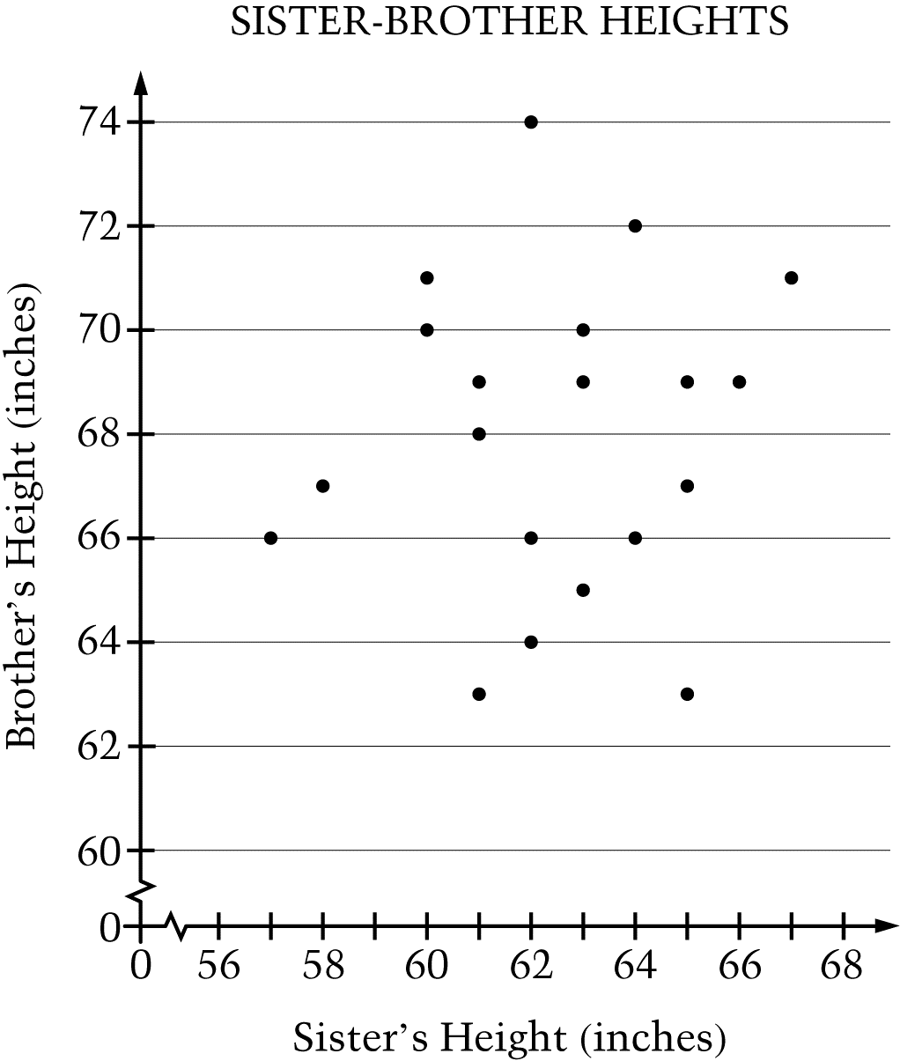
What is the brother’s height that corresponds to the tallest sister’s height?
a.. 74 inches
b. 71 inches
c. 67 inches
d. 66 inches
e. 62 inches
NAEP grade 8, 2013
Answer: b) 71 inches
2.
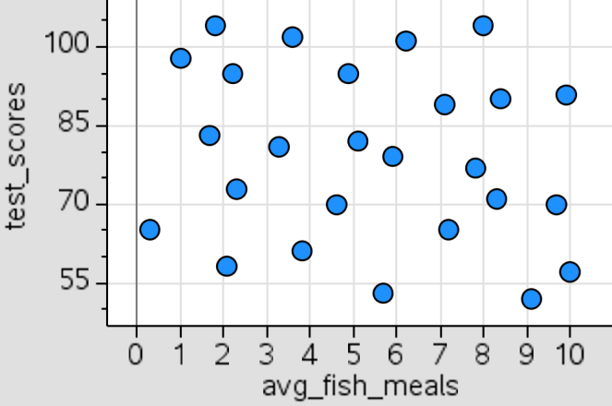
For a science project, Marsha made the scatter plot above that gives the test scores for the students in her math class and the corresponding average number of fish meals per month. According to the scatter plot, what is the relationship between test scores and the average number of fish meals per month?
a. There appears to be no relationship.
b. Students who eat fish more often score higher on tests.
c. Students who eat fish more often score lower on tests.
d. Students who eat fish 4-6 times per month score higher on tests than those who do not eat fish that often.
e. Students who eat fish 7 times per month score lower on tests than those who do not eat fish that often.
NAEP 2007 grade 8
Answer: a) There appears to be no relationship.
3.
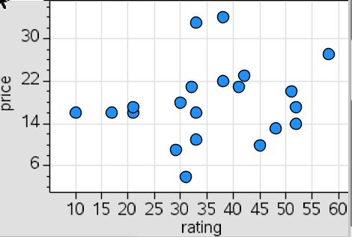
The plot shows the consumer ratings for different brands of a tool.
a. Estimate the highest rating for any of the brands.
Answer: 57 or 58
b. Would you buy the brand represented by (31, 4) or the one by (32, 34)? Explain your thinking.
Answer: The two brands have almost the same rating but one costs $4 and the other $34, so I would buy the cheaper one.
c. If you were willing to pay about $15 for the tool, what brand would you look for?
Answer: a brand with a rating greater than 50
4. The plot below represents the average yearly temperature in degrees Fº and rainfall in inches for states in the western United States.
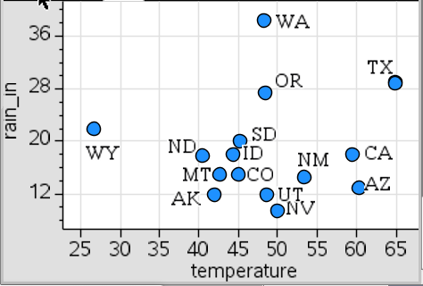
- Which state has the highest yearly amount of rain?
Answer: Washington
- Estimate the average temperature and rainfall in Arizona.
Answer: 60º and about 12 inches of rain per year.

Student Activity Solutions
In these activities you will interpret points represented in a scatter plot in terms of the context represented by the paired variables. After completing the activities, discuss and/or present your findings to the rest of the class.
Activity 1 [Page 1.3]
1. Plot (average number of points per game, average number of rebounds per game).
- Identify any points that strike you as “outliers” —points that lie quite outside of the general set of points. Who are the players and how do they compare to the other players?
Answer: Wilt Chamberlain, in the top right corner, averaged 30.1 points per game and 22.9 rebounds, clearly better than all of the other players with respect to both variables. Bill Russell, towards the top a bit left of the middle, averaged 22.5 rebounds per game but was lower than most of the other players with respect to the average number of points, 15.1. Dennis Rodman has the least number of average number of points per game but is just over 3 less than Wes Unseld scored.
b. Identify the players with the least number of rebounds per game. How did they do with respect to points per game?
Answer: The player with the lowest average number of rebounds per game was Tiny Archibald with 2.3. Lots of other players were close however, and they all, including Archibald, had between 13 and 19 points per game, towards the lower end of all the players.
2. Basketball players generally play one of five positions, center, point guard, shooting guard, small forward, and power forward. Plot (average number of rebounds, field goal percentage). Select menu> Position, and experiment with the different positions with respect to the plot.
a. What are some observations you have with respect to any association between position and either rebounds or points scored?
Answers may vary. The centers are the ones who make most of the rebounds per game, typically 9 to 17, and scored more rebounds than all but six of the other players. Russell and Chamberlain were “outliers”- scoring 22.5 and 22.9 rebounds per game averaging about 6 more rebounds than the next highest center, Bob Pettit at 16.2. Some of the centers had a high field goal percentage (like Shaq O’Neal with 58.2%, Dwight Howard with 57.9% or Kareem Abdul-Jabbar with 55.9%) and others hardly any (like Dolph Schayes with 38%).
b. Change the vertical axis to number of assists (an assist is a situation in which one player passes the ball to a teammate who makes a basket). What do you observe?
Answers may vary. The centers make more rebounds than all but seven of the other players, but none of them made more than a bit over 4 assists.
c. Plot (free throw percentage, three point percentage). Describe where the players in different positions seem to cluster in the plot.
Answers may vary. Shooting guards, with the exception of Dennis Johnson, and small forwards seem to cluster in the upper right of the plot, with high percentages in both categories. Point guards are also clustered in the upper right corner, with relatively high percentages for both but maybe not quite as strong as the other shooting guards and small forwards. All but four of the centers make less than 25% of their three point shots. Power forwards are mixed.
Activity 2 [Page 1.3]
1. Does there seem to be an association or relationship between the statistics in each of the following scatter plots? Explain your thinking.
a. (field goal percentage, three-point percentage)
Answers may vary. Not really any relationship; the points are scattered all over with no real pattern, so there does not seem to be any association between field goal percentages and three-point percentages. If you moved the three points in the lower right (Abdul-Jabbar, Howard, O’Neal), the points do not show any real trend.
b. (average number of rebounds per game, average number of points per game)
Answer: No association. Michael Jordan made a lot of points (averaged 30.1 but only 7 rebounds per game; A bunch of players were in the lower left corner with less than 7 rebounds and less than about 16 points. Elgin Baylor made more than 13 rebounds a game and scored an average of 27.4 points per game down to Wes Unseld who scored about the same number of rebounds but on 10.8 points per game, with a whole cluster of players in between these with no pattern.
c. (average number of rebounds per game, free throw percentage)
Answer: The players with few rebounds had fairly high free throw shooting percentage (mostly the guards) and those with a lot of rebounds had lower shooting percentage (mostly centers). The trend is almost in reverse.
d. (three point percentage, free throw percentage)
Answer may vary. Except for Wes Unseld, there seems to be a strong association between the two variables. Those who have low percentages for three pointers also have low percentages for field goals and those with high percentages for three pointers have high percentages for field goals. Interesting to note that all of the centers but three (Garnett, Nowitzki and Robinson) were those with low percentages on both variables.
2. Remember earlier work graphing functions and equations, where one of the variables was an independent variable and the other was the dependent variable. In statistics, the dependent variable is often called the response variable.
a. What do you think is meant by a “response variable”? Which axis will contain the response variables?
Answers may vary. A dependent variable is one that is determined by the value of the independent variable, so it makes sense to think of the response variable as the one predicted by the independent variable. The vertical axis will contain the response variables.
b. Think about the plots in questions 1 and 2. In which of the plots could there be a response variable? Explain your reasoning.
Answers may vary. If there is no association, either variable could be the response variable. In question 1, it could make sense to say that the number of points scored depends on how long a player was in the game; that is the length of time a player is in the game can be used to get a rough prediction of the number of points the player might make, on average. In c) the trend is really a function of position played, where the guards are better at shooting free throws and the centers at rebounding. menu> Position> Shooting Guard will display all the shooting guards; then cursor over to identify and highlight the point guards to see the distribution. In d) (three point percentage, field goal percentage), while there is an association between the variables, the percentage of three point shots a player makes might predict his field goal percentage but it could also be thought of as the other way around.

