Math Objectives  - Students will explore geometric sequences and series.  - Students will consider the effect of the value for the common ratio and first term using the Transfrm App for the TI-84 CE.  - Students will graphically analyze the geometric series using graphs.  - Students will try to make a connection with how to understand these topics in IB Mathematics courses and on their final assessments.  Vocabulary  - Geometric Sequence • Common Ratio • Diverge  - Geometric Series • Converge  About the Lesson  - This lesson is aligning with the curriculum of IB Mathematics Applications and Interpretations SL/HL and IB Mathematics Approaches and Analysis SL/HL  - This falls under the IB Mathematics Core Content Topic 1 Algebra:  1.3a Geometric sequences and series  1.3b Use of the formula for the n^{th} term and the sum of the first n terms of the sequence  1.3d Applications  - As a result, students will:  Apply this information to real world situations  Teacher Preparation and Notes  - This activity is done with the use of the TI-84 family as an aid to the problems, specifically the Transfrm App.  - This activity serves as a nice introduction to geometric series.  Activity Materials  - Compatible TI Technologies:  TI-84 Plus*, TI-84 Plus Silver Edition*, TI-84 Plus C Silver Edition, TI-84 Plus CE  * with the latest operating system (2.55MP) featuring MathPrintTM _{functionality.} | 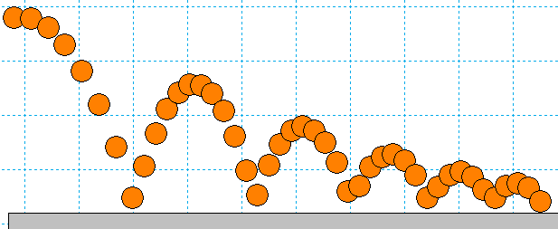  Tech Tips:  - This activity includes screen captures taken from the TI-84 Plus CE. It is also appropriate for use with the rest of the TI-84 Plus family. Slight variations to these directions may be required if using other calculator models.  - Watch for additional Tech Tips throughout the activity for the specific technology you are using.  - Access free tutorials at http://education.ti.com/calculators/pd/US/Online-Learning/Tutorials  Lesson Files:  Student Activity  Exploring_Geometric_Sequences_Student-84.pdf  Exploring_Geometric_Sequences_Student-84.doc
Example of Geometric Sequence
The height that a ball rebounds to after repeated bounces is an example of a geometric sequence. The top of the ball appears to be about 4.0, 2.8, 2.0, and 1.4 units. If the ratios of consecutive terms of a sequence are the same, then it is a geometric sequence. The common ratio r for these values is about 0.7.
Demonstration: $r ≈ \frac{2.8}{4.0}=0.7 ≈ \frac{2.0}{2.8} ≈0.71 ≈ \frac{1.4}{2.0}=0.7$
Problem 1 – Changing the Common Ratio
Explore what happens when the common ratio changes.  Start the Transfrm App. Press o and for Y1, enter 4∗A^(X–1).  Change your settings by pressing p and arrow right to go to SETTINGS. Set A = 0.7 and Step = 0.1.  Graph the function by pressing q and selecting ZStandard. Change the value of the common ratio (A).  1. Discuss why you think the r-value is called the common ratio.  Possible discussion points: The ratios of consecutive terms are the same; they have that in common.  2. With a classmate observe what happens when you change the common ratio from positive to negative. Explain why this happens.  Possible discussion points: The smooth continuous graph  disappears. The y values of the graph oscillate between  positive and negative values.  3. If each output from this function was a term in a geometric sequence, describe what would happen if you added all the terms of this sequence. Explain what common ratio conditions that would be needed so that the sum will diverge, (get larger, and not converge to some number). Use the table functions on the handheld as an aid.  Possible discussion points: The sum would converge to  some finite value. If r is greater than or equal to 1, the sum will  diverge. |  | 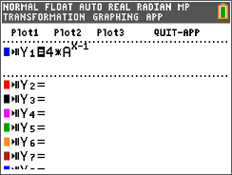  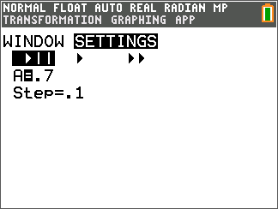  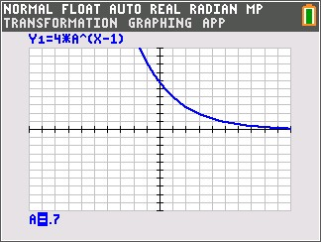
4. When the common ratio is larger than 1, explain what happens to the graph and values of y.
Possible discussion points: The graph increases from left to right making the
values of y larger.
5. Discuss with a classmate the r-values that could model the heights of a ball bounce. Share your
results with the class.
Possible discussion points: The r-value would be between 0 and 1 because the height of the ball
becomes smaller with each bounce.

Problem 2 – Changing the Initial Value and the Common Ratio
Press o and change Y₁ to B∗A^(X–1).  Change the p SETTINGS so that A=0.7, B=4 and Step=0.1.  6. Explain your observations of what happens when $b$ changes. Describe, in the context of a real world problem, what $b$ is also known as.  Possible discussion points: The graph becomes more steep.  $b$ is the initial value.  7. Discuss with a classmate which variable seems to have a more  profound effect on the sequence. Share your results with the  class.  Possible discussion points: This question can spawn some  constructive discussion. Students may have differing opinions.  Further Discussion  If time permits, Discuss how the bouncing ball data was  generated in the picture at the beginning, making connections to the modeling of real world quadratic data, quadratic transformations, and gravity. Finally, discuss how the bouncing ball connects to geometric sequences.  Possible discussion points: This is a great opportunity to use motion sensors or high speed digital cameras to collect and model data of bouncing balls. You can then discuss that the parabolas are basically have the same “a” values but are only translated, and then you can discuss the “a” value of each parabola and how close it is to the value of gravity. | 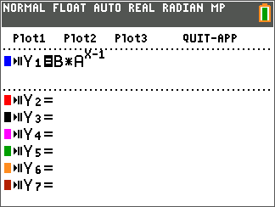  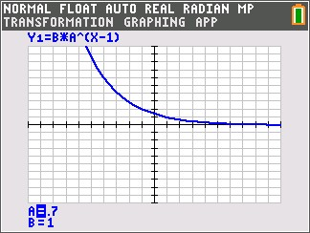
Extension – Deriving and Applying the Partial Sum Formula
The sum of a finite geometric series can be useful for calculating funds in your bank account, the depreciation of a car, or the population growth of a city.
e.g. $S_{6}=4+8+16+32+64+128$
In this example, the common ratio is 2, the first term is 4, and there are 6 terms.
The general formula:
$S_{n}= a_{1}+ a_{2}+ a_{3}+…+ a_{n-1}+ a_{n}$
Because $a_{n}=r∙a_{n-1}$, substituting gives
$$S_{n}= a_{1}+r∙a_{1}+ r^{2}∙a_{1}+ r^{3}∙a_{1}+…+ r^{n-2}∙a_{1}+ r^{n-1}∙ a_{1}$$
$$r∙S_{n}=r∙ a_{1}+ r^{2} ∙ a_{1}+r^{2} ∙ a_{1}+…+ r^{n-1} ∙ a_{1}+ r^{n} ∙ a_{1}$$
Subtract the previous two lines.
$S_{n}-r ∙ S_{n}= a_{1}- r^{n} ∙ a_{1}$
$S_{n}\left(1 -r\right)= a_{1}(1 - r^{n})$
So, $S_{n}= a_{1} ∙ \frac{1 - r^{n}}{1 - r}$

Use the formula to find the sum of the following finite geometric series.
8. Find $S_{5}$ for $a_{n}=6{\left(\frac{1}{3}\right)}^{n-1}$.
Solution: $S_{5}= \frac{6\left(1- {\left(\frac{1}{3}\right)}^{5}\right)}{1- \frac{1}{3}}= \frac{242}{27} ≈8.96$

9. =
Solution: $S_{6}= \frac{\frac{1}{7}\left(1- {\left(\frac{1}{7}\right)}^{6}\right)}{1- \frac{1}{7}}= \frac{19608}{117649} ≈0.167$

10. Find $S_{25}$ for $a_{n}=2{\left(1.01\right)}^{n-1}$.
Solution: $S_{25}= \frac{2\left(1- {1.01}^{25}\right)}{1-1.01} ≈56.5$

11. =

Solution: $S_{15}= \frac{64\left(1- {\left(-\frac{1}{2}\right)}^{15}\right)}{1- \left(-\frac{1}{2}\right)}= \frac{10923}{256} ≈42.7$

Further IB Extension
Mac was trying out a new cheesecake recipe. Once completed, he will be serving it to his family. Loving the art of math, he decides to cut the slices using the cheesecake’s volume. Each slice will represent a term in a geometric sequence, with the smallest being cut first.
The second smallest slice has a volume of $80 {cm}^{3}$. The fourth smallest slice has a volume of $1280 {cm}^{3}$.
- Find the common ratio. [2 marks]
Solution: $u_{n}= u_{1}∙ r^{n-1}$
$u_{2}= u_{1} ∙ r^{2-1}$ and $u_{4}= u_{1} ∙ r^{4-1}$
$80= u_{1}∙r$ and $1280= u_{1} ∙ r^{3}$
$\frac{1280 = u_{1} ∙{ r}^{3}}{80 = u_{1} ∙ r}$
$r^{2}=16$
$r= ±4$, since the volumes are all positive,
$r=4$

- Find the volume of the smallest slice. [2 marks]

Solution: $u_{n}= u_{1}∙ r^{n-1}$
$80= u_{1} ∙ 4^{2-1}$

$80=4 ∙ u_{1}$
$u_{1}=20 {cm}^{3}$

- The cheesecake has a total volume of $27,300 {cm}^{3}$, find how many family members get
to try Mac’s delicious cheesecake.
[2 marks]

Solution: $S_{n}= \frac{u_{1}\left(1- r^{n}\right)}{1-r}$
$27,300= \frac{20\left(1- 4^{n}\right)}{1-4}$

$27,300= \frac{20\left(1- 4^{n}\right)}{-3}$
$-81,900=20\left(1- 4^{n}\right)$
$-4095=1- 4^{n}$
$-4096= -4^{n}$
$4096= 4^{n}$
${Log}_{4}{4096=n}$
$n=6$

Teacher Tip: Please know that throughout this activity there is a lot of time dedicated to students talking with one another and sharing their thoughts with the class. The goal here is to not only review Geometric Sequences and Series, but also to generate discussion.

**Note: This activity has been developed independently by Texas Instruments and aligned with the IB Mathematics curriculum, but is not endorsed by IB™. IB is a registered trademark owned by the International Baccalaureate Organization.

